Muhammad Abdullah 10022, Syed Sualeh Abbas 10303

Lab 1: Getting Started with RISC-V (Assembly Language) in VS Code

GITHUB REPO LINK: Click Here

Task 1:

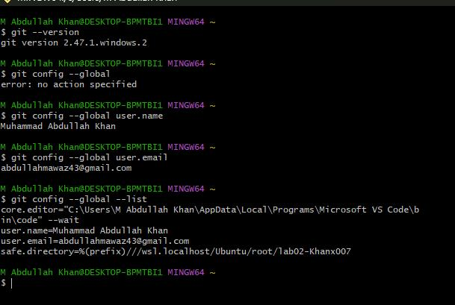

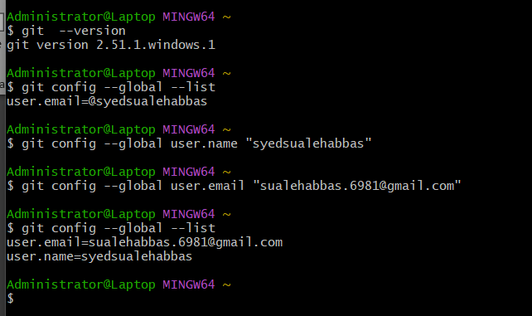/

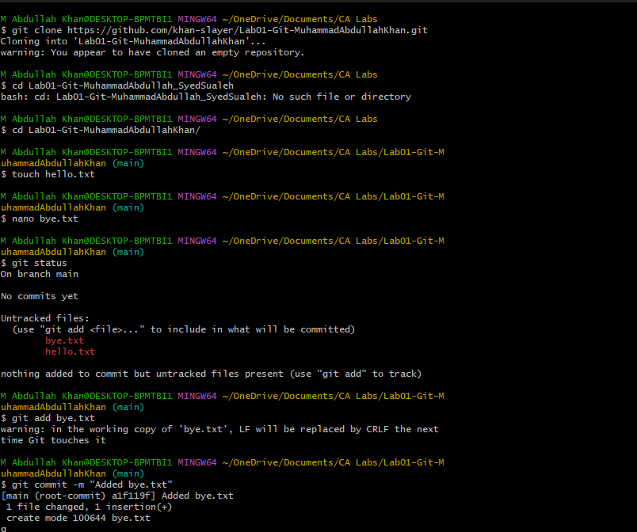

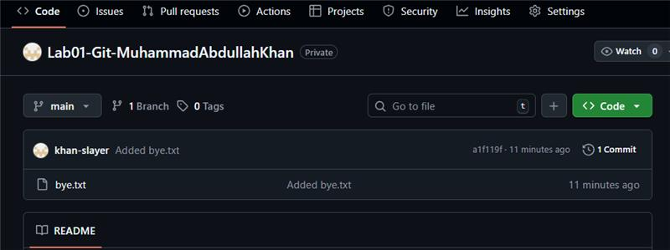

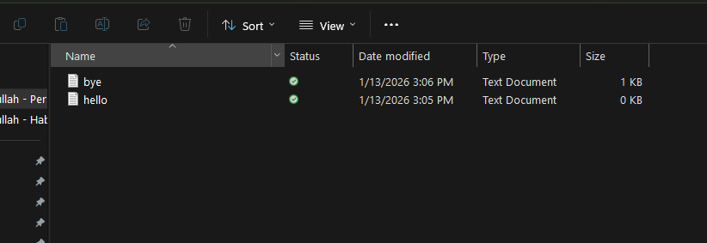

Task 02: Setting Up VS Code (RISC-V Simulation Environment)

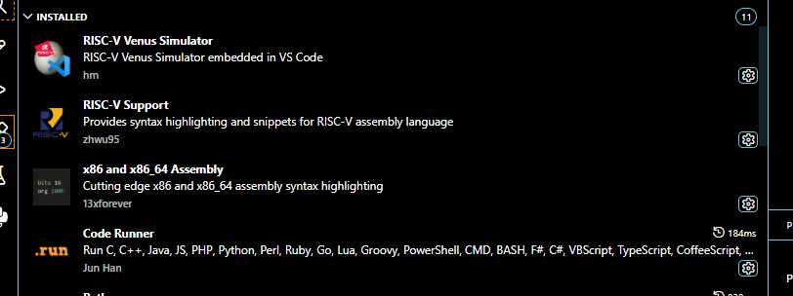

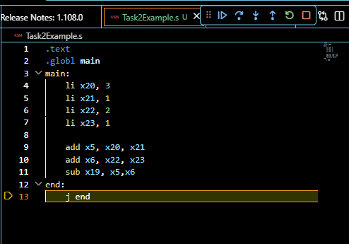

VIEWING REGISTER VALUES:-

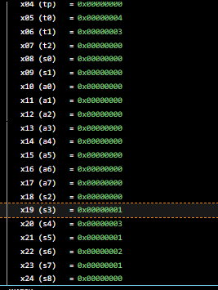

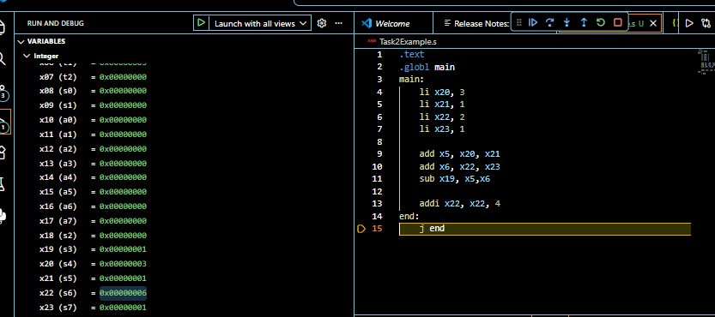
EXAMPLE # 2:

Figure 1.4: RISC-V Memory

Task 3
Convert the following statement to RISC V. You can use the same registers as given in

1
int a = 5;
int b = 0 + 0; a = b + 32;
int d = (a + b) - 5;
int e = (((a - d) + (b - a)) + d); e = a + b + d + e;

2

3

4

5

Task 3

Code

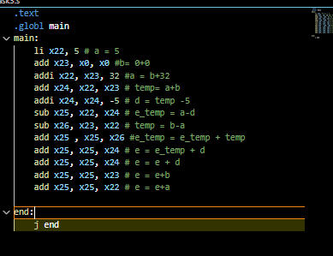

Output

Desired output:

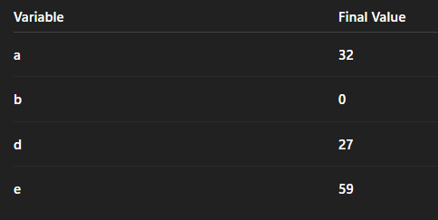

Output:
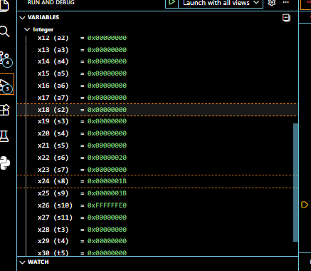

Hence same as desired output.

Task 4a
Initialize the register x10 and x11 with values 0x78786464, 0xA8A81919, respectively manually.
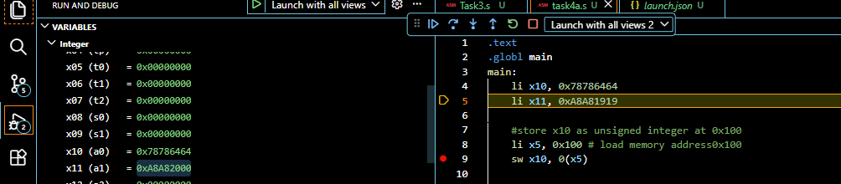

Write the RISC-V assembly code for each item below. Try guessing the result in each destination before executing the instruction and corroborate it after execution:
Store x10 as unsigned integer at address 0x100.
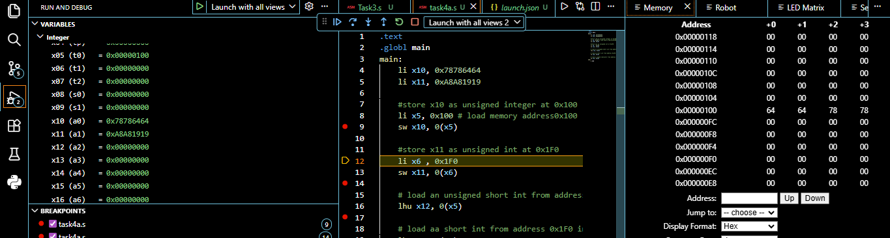

Store x11 as unsigned integer at address 0x1F0.
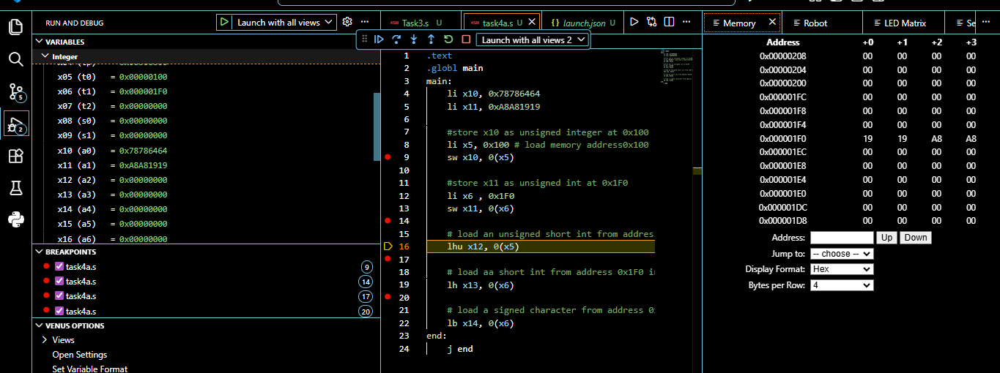

Load an unsigned short integer (two bytes) from address 0x100 in x12.
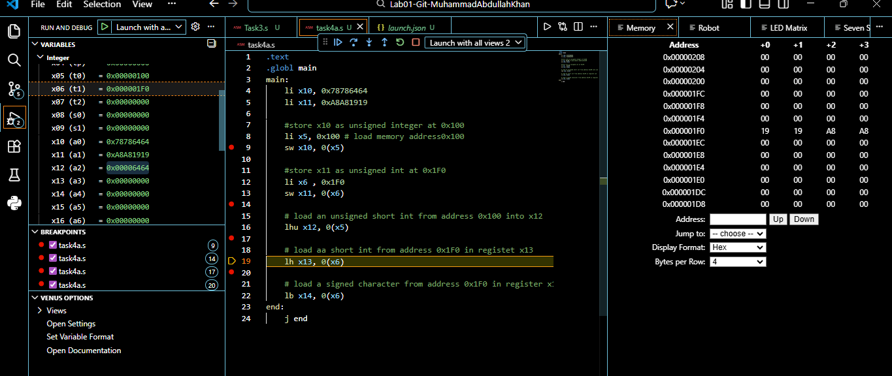

Load a short integer from address 0x1F0 in register x13.

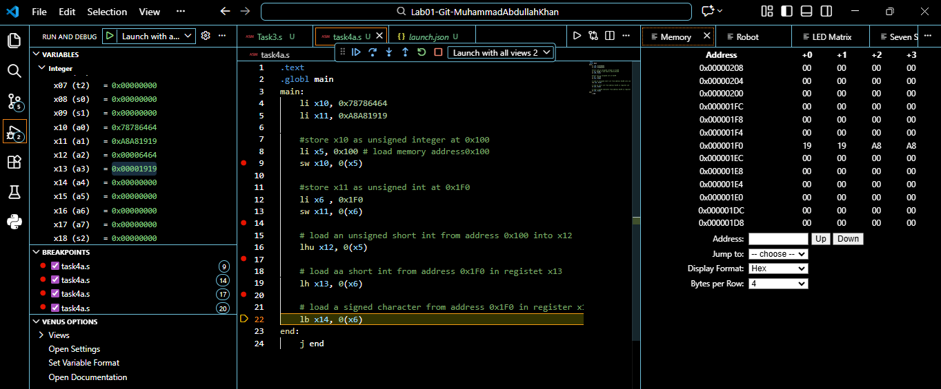

Load a singed character from address 0x1F0 in register x14.
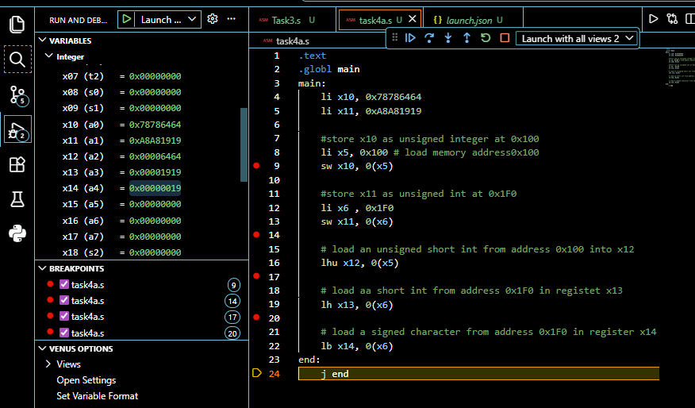
Task 4b – - Loop unrolling

1

Assume there are three character arrays a, b, and c located at addresses 0 x100 , 0x200 , 0 x300 respectively.
for (int i=0 ; i<4; i++ )
c [ i ]=a [ i ]+b [ i ] ; # c [ 0 ]=a [ 0 ]+b [0 ] ;
Write equivalent RISC -V code for the piece of code given. You have not studied loops yet, but the above code is manageable without loop instructions. Also assume that A is a character array , B is a short array
, and C is an unsigned integer array.

2

3

4

5

6

7

Code

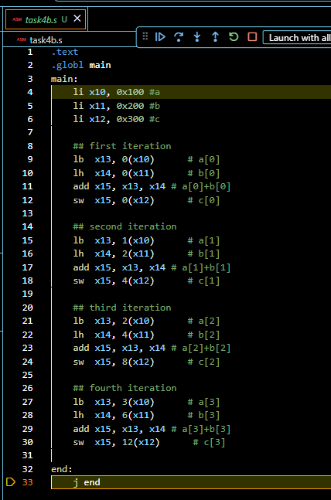

Output

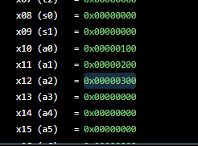

Hence all addresses are stored in the registers.

Assessment Rubric
Lab 1: Getting Started with RISC-V (Assembly Language) in VS Code

Name: Syed Sualeh, Abdullah Khan | Student ID: 10303, 10022 | section*: T4

Points Distribution

 | Task No. | LR 2  Code | LR 5  Results
In - Lab | Task 1 | /0 | /15
In - Lab | Task 2 | /0 | /15
In - Lab | Task 3 | /10 | /5
In - Lab | Task 4a | /10 | /5
In - Lab | Task 4b | /10 | /10
Total Points: 100 |  | /30 | /50
CLO Mapped |  | CLO 2

Affective Domain Rubric |  | Points | CLO Mapped
AR7 | Report Submission & Git Upload | /10 & /10 | CLO 2

CLO | Total Points | Points Obtained
2 | 100
Total | 100

For description of different levels of the mapped rubrics, please refer to the Lab Evaluation Assessment Rubrics and Affective Domain Assessment Rubrics provided here.

